Habitat Stewardship Program (HSP) – ECCC-CWS Atlantic Region
Expression of Interest 2024-2025
Project Title
Project province(s) and location(s)
Applicant information (This is the organization that would sign a Contribution Agreement with Environment and Climate Change Canada if the application is approved.)
Name of applicant
Organization
Address
Phone number
Email address
Other communities/organizations involved in the Project (if partnering). Include both funding contributors and key stakeholders in the Project.
HSP Program Priorities addressed
Does your project target one or more HSP 2024-2025 Atlantic Region Priority Species? Please check all that apply.
☐ Leach’s Storm-Petrel | ☐ SARA-listed forested wetland species (Canada Warbler, Olive-sided Flycatcher, Rusty Blackbird)
Monarch and SARA-listed pollinators (Yellow-banded Bumble Bee, Gypsy Cuckoo Bumble Bee, Suckley’s Cuckoo Bumble Bee, Macropis Cuckoo Bee) | ☐ SARA-listed reptiles (Wood Turtle, Eastern Painted Turtle, Snapping Turtle)
☐ Piping Plover melodus subspecies | ☐ SARA-listed swallow, swifts and nightjar species (Bank Swallow, Barn Swallow, Chimney Swift, Common Nighthawk, Whip-poor-will)
☐ SARA-listed bat species (Little Brown Myotis, Northern Myotis, Tri-coloured Bat) | ☐ SARA-listed thrush species (Bicknell’s Thrush, Wood Thrush)
☐ SARA-listed Lichens (Boreal Felt Lichen – Atlantic population, Vole Ears Lichen, Black-foam Lichen; Blue-felt Lichen, Boreal Felt Lichen- Boreal population, Eastern Waterfan, Frosted Glass-whiskers-Nova Scotia population, Wrinkled Shingle Lichen, White-rimmed Shingle Lichen)
If applicable, please list all targeted species at risk that are not included in the priority species list above, including their SARA status or COSEWIC assessment level.
Does your project address one or more Priority Sectors and/or Threats? Please check all that apply.
Priority Sector | Priority Threat
☐ Agriculture | ☐ Invasive Alien Species
☐ Forestry | ☐ Wildlife Disease
☐ Urban Development | ☐ Illegal Wildlife Trade
If you selected one or more Priority Sector and/or Threat, please describe very briefly how your project addresses it/them.
Does your project occur in one or more Federal-Provincial-Territorial or Community-Nominated Priority Places? (Please see Appendix for map of Priority Places.)
☐ Yes ☐ No
If yes, please list the Priority Place(s).
Proposed project: Briefly describe the project—goals, objectives, activities, methods, partnerships and time frame. Please ensure that you show clear links between your project’s target species, threats addressed and activities proposed to reduce these threats.
Budget: Please provide an estimate of only the ECCC funding amount(s) to be requested. Keep in mind that eligible (non-federal) minimum match requirements are 1:1 for non-Indigenous recipients and 0.2:1 for Indigenous recipients.
2024-20251 | 2025-2026 | 2026-2027 | 2027-2028 | 2028-2029 | Total HSP ask
$ | $ | $ | $ | $ | $
Permitting: It is your responsibility to acquire the necessary permits for the proposed project. Have you considered the permits that need to be acquired prior to initiation of project activities?
☐ Yes ☐ No
As permits take time to arrange, you should address this need several months before the project start date to reduce delays once a funding arrangement is made. Please contact your HSP coordinator if you have questions.
Email completed form to Delphine.Seto@ec.gc.ca by October 5, 2023. Early submissions are encouraged to allow for adequate time for feedback.

Appendix: Federal-Provincial-Territorial and Community-Nominated Priority Places in Atlantic Canada.
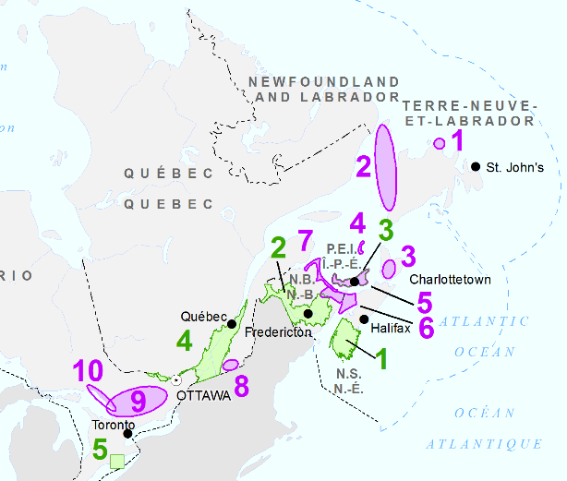
LEGEND

Federal-Provincial-Territorial Priority Places

1. Kespukwitk / Southwest Nova Scotia
2. Wolastoq / Saint John River
3. Forested Landscape
Community-Nominated Priority Places

1. Cape Freels
2. Long Range Biodiversity
3. Maliamu’kik msit ko’kmanaq / Taking care of all our relations
4. Îles-de-la-Madeleine (Quebec Region)
5. North Shore Prince Edward Island
6. Sikniktewaq / Chignecto Isthmus
7. Wele’k Pemjajika’q Siknikt / Healthy Coasts New Brunswick

Please note that new projects can only be a maximum of three years. ECCC will aim to have HSP funding decisions available by early summer 2024; please plan accordingly.

