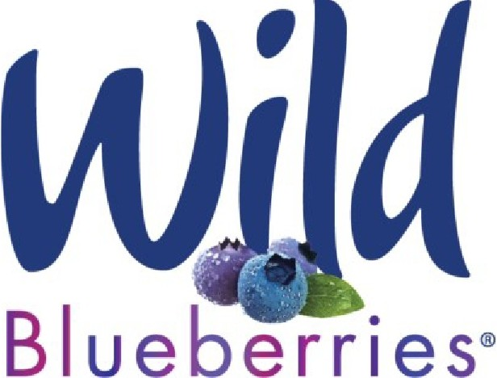

Wild Blueberry Fact Sheet &
Working With the Wild Blueberry Association of North America

We hope that these notes will be helpful in your research and future publications about Wild Blueberries, as well as your WBANA-supported projects.

Composition of Wild Blueberries
- USDA Nutritional Analysis of blueberries can be found in the “Legacy” data at https://fdc.nal.usda.gov/fdc-app.html#/food-details/173949/nutrients
- For general composition of Wild Blueberries see [4]

Describing Wild Blueberries
- Common name – Wild, lowbush blueberries
- Species name - Vaccinium angustifolium
- Description –Plants (approx. 5-12” tall) spread outward, providing continuous plant coverage across fields
- Because they are wild, blueberry fields are genetically very diverse.
- Harvested Wild Blueberry are a blend of copious genotypes
- For photos and more information see https://www.wildblueberries.com/why-wild/growing-harvest/

Wild vs. Regular Blueberries
- Wild, lowbush blueberries = Vaccinium angustifolium and V. myrtilloides
- Regular, highbush blueberries = Vaccinium corymbosum and V. virgatum .
- Wild blueberries are a complex mixture of genotypes whereas; regular commercial blueberries have only a few genotypes or varieties in each field.
- Wild blueberries are harvested commercially only in the northeastern North America whereas regular blueberries are grown commercially throughout the world.
- Comparison of Wild and regular highbush blueberries see [3]

About WBANA’s Wild Blueberry Powder for Research Use
- Whole wild blueberries are collected from the major production regions and blended in proportion to each region’s total production.
- Mixture of whole wild blueberries (including peel, seed, and flesh) are freeze dried and milled into a powder.
- Silica dioxide (1%) is added to prevent clumping of the berry powder.
- Freeze drying and bulk packaging of current batch of powder was completed by Mercer Foods, LLC 1836 Lapham Drive Modesto, CA 9535.

Information Specific to WBANA’s Current Wild Blueberry Powder
- Currently in production; Certificate of Analysis will be available
- Percent moisture at time of production: typically 4% or below

- Powder is tested for microbiological safety and for human allergens (allergen statement available)
- Recommended handling – avoid moisture, keep sealed and store in freezer (sub-zero recommended) until needed.
- Methods for Analysis of total phenolic and anthocyanins
  - Anthocyanins [1]
  - Total Phenolics [2]
- Conversion of mass of dry powder to volume of fresh berries: Assume that fresh blueberries contain 85% water and 15% solids [3]. Average size of fresh Wild blueberry fruit are between 0.15g and 0.3 g per berry [3]. One cup of Wild Blueberries weighs about 120 g.
- The dry-down ratio information for the previous batch of powder:
  - 14.6% FD yield (indicates 14.6g freeze-dried blueberry powder obtained from 100g fruit). Hence the dry down will be 100/14.6 = 6.849.
  - Ratio of fresh/frozen blueberry to FD blueberry powder = 6.849:1. So, 1 g FD powder is equivalent to 6.849 g of fresh/frozen WB for the previous batch.

Acknowledging WBANA
- If you are using Wild Blueberries, Wild Blueberry powder or placebo provided by WBANA in your project, we request that you refer to the product as “wild blueberry” in your published work/project—including in the title and the title of any published papers related to the project.
- Acknowledgement of research support from WBANA can be identified with the following information: Wild Blueberry Association of North America, Old Town, Maine 04468 USA
- The current WBANA logo jpg is at the top of this document; other formats can be requested.

Literature Cited
1. Wrolstad, R.E.; Durst, R.W.; Lee, J. Tracking color and pigment changes in anthocyanin products. Trends Food Sci. Technol. 2005, 16, 423–428.
2. Singleton, V.L.; Rossi, J.A. Colorimetry of Total Phenolics with Phosphomolybdic-Phosphotungstic Acid Reagents. Am. J. Enol. Vitic. 1965, 16, 144–158.
3. Kalt, W.; Ryan, D.A.J.A.J.; Duy, J.C.C.; Prior, R.L.L.; Ehlenfeldt, M.K.K.; Vander Kloet, S.P.P. Interspecific variation in anthocyanins, phenolics, and antioxidant capacity among genotypes of highbush and lowbush blueberries (Vaccinium section cyanococcus spp.). J. Agric. Food Chem. 2001, 49, 4761–4767.
4. Kalt, W.; McDonald, J.E. Chemical composition of lowbush blueberry cultivars. J. Am. Soc. Hortic. Sci. 1996, 121, 142–146.

2/2024

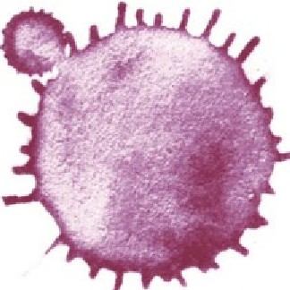
WILD BLUEBERRY ASSOCIATION OF NORTH AMERICA

P: 207.570.3535 I F: 207.581.3499 I wildblueberries.com

