
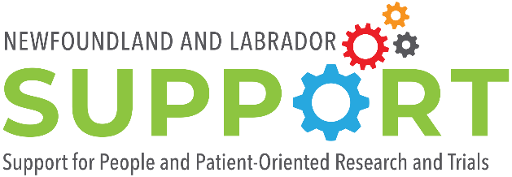

Fall 2024

Health Professional-led Research Funding

The purpose of the Health Professional-led Research Funding is to develop patient-oriented research and evaluation capacity amongst health professionals and to enable the creation of learning cycles in health and social care in Newfoundland and Labrador. We anticipate running two competitions per financial year and up to five grants will be funded per annum.
Tenure and Value of Award

Funding will be available to successful applicants starting in January 2025. The value of this award will be up to $10,000 per project. The award is for one year. All projects funded under this award must be completed prior to March 31, 2026.
We highly encourage the evaluation of patient engagement in all work funded by NL SUPPORT. Please review Learning Together: Evaluation Framework for Patient and Public Engagement (PPE) in research for information about indicators to consider when evaluating patient engagement. Following completion of the research project, we will ask all members of the research team to report on patient engagement using a standard survey to outline how patients were involved in the project.
Eligibility

The purpose of the Health Professional-led Research Funding is to encourage clinical staff to conduct research/evaluation, preferably on an issue they have identified through their clinical work. Applicants must therefore be a clinician, nurse or other health professional working actively in a clinical role within a research, health or community care institution in Newfoundland and Labrador.
Applications for Health Professional-led Research Funding will be judged according to the following selection criteria by a review committee comprised of NL SUPPORT/Quality of Care NL staff, health professionals and patient/public partners:
- Incorporation of patients/members of the public as partners rather than subjects throughout the project’s lifecycle;
- Expertise and research experience, and past contributions to patient-oriented research and related fields;
- Merit of the proposal, based on:
  - Potential for meaningful real-world outcomes and application to a learning cycle component of the Learning Health and Social System in Newfoundland and Labrador
  - Quality and clarity of research/evaluation question
  - Originality
  - Potential contribution to patient-oriented research
  - Scalability of the proposed work
  - Relevance to health-related decision-making
  - Systems improvement or positive patient impacts
  - Value to the health care system
  - Considerations for Equity, Diversity and Inclusion and Sex and Gender-Based Analysis Plus (EDI/SGBA+)
- Clarity of presentation and appropriateness of design and research/evaluation plan
- Feasibility of the proposed work
- Appropriateness and justification of the budget
How to Apply

Please submit your application package in an electronic format (PDF, Microsoft Word) to Chelsey McPhee (chelsey.mcphee@mun.ca).

Please use the subject title: Health Professional-Led Funding application – Name of study lead, date submitted.
Applications must be received by 5:00 p.m. Newfoundland Time on December 31, 2024.

Memorial University applicants should contact their academic departments regarding internal deadlines. Applications must be approved by the applicant’s faculty/school prior to submission. Please consult the list of Grant Facilitators & Research Officers at Memorial to determine who to contact regarding internal deadlines, if you do not know who to contact. Please ensure you contact your faculty/school for approval well in advance of the submission deadline. Applications that have not been approved by your faculty/school, are late or incomplete will not be accepted.

Please Note:
- Applicants will be informed via email whether their application was successful or not.

- Grant funds will be released only upon the receipt of a letter of approval from the appropriate ethics review committee, when ethics approval is necessary. If your project involves and/or impacts Indigenous groups, peoples and/or lands, award funds will not be released until proof of community approval is submitted.

- Once an application has been funded, major changes in the project design will require prior approval from the NL SUPPORT/Quality of Care NL review committee.

- Funding will be issued by way of Letter of Agreement issued to the Host Institution.

- Research teams can only hold one Health Professional-led Research Funding from NL SUPPORT at a time.

- Successful projects will be required to join and provide updates to the NL SUPPORT/Quality of Care Learning Health and Social System Committee, which meets once every two months.

For further information or clarification on the application guidelines, please contact Chelsey McPhee at chelsey.mcphee@mun.ca.

Application Package Checklist
 | Section | Information on page(s):
☐ | Part 1: Research/Evaluation Team | 3
☐ | Part 2: Project Information | 4 - 5
☐ | Part 3: Ethics/Indigenous Research Agreement | 6
☐ | Part 4: Host Institution Signatures | 7
☐ | Part 5: Demographic Questionnaire | 8 - 9

Part 1: Research/Evaluation Team
Study Lead | The study lead is the person responsible for the project. The study lead for the Health Professional-led Research Funding should be a health professional working actively in a clinical role. Please include the Study Lead’s job title and email address.  Please refer to the Eligibility section on Page 1 for more information.
Study Team | It is expected that research will be conducted by multi-disciplinary teams in collaboration with all knowledge users where patients/people with lived experience, researchers and health professionals work together to contribute to improved and sustainable health systems and outcomes. Please list the names, job titles (where relevant) and roles of any additional members of the study team.  Roles may include (but are not limited to):  - Co-lead (please include email address)  - Collaborator (please indicate the areas that they will be collaborating on)  - Knowledge user (please indicate the lived / work experience that they bring to the team)  - Patient Partner/person with relevant lived experience  - Research/evaluation assistance  - Others roles as appropriate

Part 2: Project Information

Applicants must provide a summary (4 pages maximum, letter size, single spaced, Arial 10 font, 2cm margins) of their proposal which includes the following sections:
Title | Please indicate whether this project is research (the intent is generalizable knowledge) or evaluation (evaluates a current or existing program for assessment, management or improvement purposes).
Plain Language Summary | This is a clear and concise statement of the problem you are going to investigate in your work. Provide some background of your topic, including appropriate literature references and/or local contextual knowledge (e.g. in the case of program evaluation). Provide a brief overview of the steps/methods you are going to undertake, and expected outcomes from your work, particularly for patients/the public. Please make sure that a member of the public can read and understand this summary. For information about plain language, please contact Chelsey McPhee (chelsey.mcphee@mun.ca).
Population | Briefly describe the population that will be the focus of this study (community, in-patients and/or out-patients, caregivers, family, etc.). Include considerations for Equity, Diversity and Inclusion and Sex- and Gender-Based Analysis Plus (EDI/SGBA+). For example, how will you remove barriers to the recruitment and full participation of individuals from equity deserving groups in your research project? For information about EDI in research, please visit https://cihr-irsc.gc.ca/e/52543.html.  For research involving Indigenous communities, please refer to TCPS 2, Chapter 9 and the Memorial University Research Impacting Indigenous Groups Policy.
Patient/Public Engagement | Describe how you have and/or will engage patients/members of the public as partners in your project. Patients/members of the public as partners is not the same as “people as subjects” for data collection.  For example, patient/public partners can help:  - Inform research priorities  - Design interventions  - Clarify the research questions and affirm their importance  - Define outcomes that are important  - Assist in creating a recruitment strategy  - Ensure that the methods selected are appropriate for study participants  - Review and comment on proposed data collection methods  - Assist in writing information for patients/the public  - Assist with developing documents, such as informed consent forms  - Assist in collecting and/or interpreting data  - Share results  - Develop and implement new services or programs, etc.  The activities listed above are not normally undertaken by study subjects. The activities that your patient/public partners are engaged in throughout your project should be distinct from the study population activities.  Please note that the term “patient” is overarching and is inclusive of individuals with personal experience of a health issue and informal caregivers, including family and friends. We acknowledge that not all “patient partners” wish to be referred to as such and we encourage you to use whatever language has been decided within your study team, as long as the “patient partner” role is clear.
Research or Evaluation Question | Clearly state the research or evaluation question(s) and objectives of your project. The FINER criteria highlight useful points that may increase the chances of developing good questions: Feasible, Interesting, Novel, Ethical and Relevant.
Design | Describe the ways in which you will gather your data and perform the analysis. Please emphasize whether your design has the potential to inform an ongoing learning cycle in the context you are working in. For more information about learning cycles, please see the What is a Learning Cycle? section on Page 11.
Intervention | Describe the intervention(s), if applicable, you suggest for use to improve patient care and outcomes.
Timeline | Briefly describe your timeline or include a basic timeline table. The duration for the NL SUPPORT Health Professional-led Research Funding is 12 months maximum.
Budget justification | Include a budget justification. For example, list the budget needed for research staff, knowledge dissemination, equipment, supplies, etc. In-kind contributions can also be listed. See the Eligible Costs section on Page 10 for more information.

Part 3: Ethics/Indigenous Research Agreement

Applicants must provide confirmation that any required research clearance(s) are in place, or a timeline for submission to the appropriate committee for review. Funding will not be released until applicable documentation has been received by NL SUPPORT. For more information about what clearances might be required, please refer to the following resources:

- https://rpresources.mun.ca/
- https://hrea.ca/how-to-apply/ethics-review-required/
- https://ethics.gc.ca/eng/policy-politique_tcps2-eptc2_2022.html

For information about the Research Impacting Indigenous Groups Policy at Memorial University please click here. A link to the Indigenous Research Agreement template can be found here. Please note that some local Indigenous governments have research/evaluation approval processes of their own. You must obtain all necessary agreements as outlined by each relevant Indigenous government prior to the release of funds.

If you are unsure whether you need ethics clearances, please contact Chelsey McPhee (chelsey.mcphee@mun.ca) to discuss.
Please complete the following statements:

Clearances required?
☐ Yes
☐ No

Clearances attached?
☐ To follow (please specify date) ________________________
☐ N/A

Indigenous consent (must be in place at the application stage)
☐ Required
☐ N/A

Part 4: Host Institution Signatures

Institutions that employ holders of Health Professional-led Research Funding are called host institutions. Signatures are required from host institution representatives on all grant applications.

By signing, host institutions agree to accept the responsibilities outlined below on behalf of their grant-holding employees:
- Acceptance of the terms and conditions as outlined in Funding Guide and Letter of Agreement;
- The financial administration of the grants;
- Reporting to NL SUPPORT any change in the funding recipient’s status that may affect the fulfillment of their research commitment, for example resignation or termination;
- Submission of an annual financial statement (Form 300) – a copy of which will be included in the Letter of Agreement – with back up documentation (receipts, etc.) covering the period from April 1 to March 31 for funding; the statement(s) are due no later than May 1 of each year.

____________________________________________
(Host Institution name – include department/faculty where relevant)

____________________________________________
(Host Institution representative name – printed)

____________________________________________
(Signature of Host Institution representative)

____________________________________________
(Date)

Part 5: Demographic Questionnaire
Together with the summary of their proposal, applicants are asked to please provide the answers to the following questions. Upon submission of this application, you will be sent a link to a demographics questionnaire to be circulated to the rest of your project team members. This information will not be shared with the review committee, nor will it be used in the evaluation of this application. We are collecting this information as part of the NL SUPPORT Equity, Diversity, Inclusion and Accessibility plan to better understand the demographic composition of the research teams we are supporting.
With what gender do you identify?
☐ Man
☐ Woman
☐ Non-binary
☐ Prefer not to answer
☐ Prefer to self-describe ________________________________

Please select the age bracket below that applies to you.
☐ 18-24 years
☐ 25-44 years
☐ 45-64 years
☐ 65 and over
☐ Prefer not to answer

Where were you born?
☐ Newfoundland and Labrador
☐ Canada
☐ Outside of Canada (please specify) ___________________

If you were not born in Newfoundland and Labrador, please skip this question. Are you from an urban or rural region of Newfoundland and Labrador?
☐ Urban (please specify): _______________
☐ Rural (please specify): ________________

How would you best describe yourself? (Select all that apply)
☐ White
☐ South Asian (e.g., East Indian, Pakistani, Sri Lankan, etc.)
☐ Chinese
☐ Black
☐ Filipino
☐ Latin American
☐ Arab
☐ Southeast Asian (e.g., Vietnamese, Cambodian, Laotian, Thai, etc.)
☐ West Asian (e.g., Iranian, Afghan, etc.)
☐ Korean
☐ Japanese
☐ Other (please specify) ____________________
☐ Prefer not to answer

Do you identify as Indigenous?
☐ No
☐ Yes (please feel free to specify what community you are a member of) _______________________
☐ Prefer not to answer

If so, do you identify as a two-spirit person?
☐ No
☐ Yes
☐ Prefer not to answer

Are you a member of any of the groups below? (Select all that apply or skip if none apply)
☐ Member of a rural community
☐ Newcomer to Canada (moved to Canada within the last 5 years)
☐ Visible minority
☐ LGBTQIA+
☐ People who have immigrated to Canada/NL (more than 5 years ago)
☐ People with a physical disability
☐ People who experience sensory impairments
☐ People who experience mental illness
☐ People who are neurodivergent
☐ Other (please specify) ___________________

Would you like to receive our newsletter?
☐ Yes
☐ No
☐ I already receive the NL SUPPORT newsletter

Eligible Costs

The funds are to be used for eligible expenses directly related to the research and in accordance with the Tri-Agency Financial Administration Guide – Use of Grant Funds (https://www.nserc-crsng.gc.ca/InterAgency-Interorganismes/TAFA-AFTO/guide-guide_eng.asp)

For any inquiries about eligible costs, please contact Chelsey McPhee (chelsey.mcphee@mun.ca).

Please also review the NL SUPPORT Patient/Public Partner Appreciation Guidelines for information about paying and/or acknowledging the contributions of patient/public partners.

Grantee Reporting Requirements

The successful awardees will be required to:
- Join and provide regular updates to the NL SUPPORT/Quality of Care NL Learning Health and Social System Committee
  - Awardees must be prepared to use this Committee as a resource for their projects wherein the committee can help identify additional resources, data sources, methods, knowledge users, etc., to help in the establishment of a learning cycle and the overall Learning Health and Social System in NL
- Provide an end of study report
- Present their research findings at the Quality of Care NL (QCNL) and NL SUPPORT Science, Health, and Research Education (SHARE) Summit and/or other public events or other NL SUPPORT/QCNL knowledge mobilization products
- Annual financial statement (Form 300) – See Host Institution Form on Page 7
Role of NL SUPPORT

The NL SUPPORT team will make available to applicants and grant holders as needed support services in the areas of patient engagement, knowledge mobilization and methods development. NL SUPPORT strongly encourages all successful applicants to meet with the Unit’s Patient/Public Engagement and Knowledge Translation leads throughout the duration of their project for support and guidance. Please contact Chelsey McPhee (chelsey.mcphee@mun.ca) to set up a project support meeting.

Use and Disclosure

All information requested by the Newfoundland and Labrador Support for People and Patient Oriented Research and Trials Unit (NL SUPPORT) will be used solely for the administration and management of the awards program and is collected under the general authority of the Memorial University Act (RSNL 1990 Chapter M-7). Questions about this collection and use of personal information may be directed to Chelsey McPhee (chelsey.mcphee@mun.ca).

By submitting this application to NL SUPPORT, you are certifying that all statements contained in it and in all its attachments are accurate to the best of your knowledge.

What is a “Learning Cycle”?

A learning health and social system is one in which science, education, informatics, incentives, and culture are aligned for continuous improvement, innovation, and equity. Best practices are seamlessly embedded in the delivery process, individuals and families are active participants in all elements, and new knowledge is generated as an integral by-product.
These systems are made up of individual learning cycles that exist in specific health and social care contexts. Within each learning cycle an opportunity or challenge is identified and key knowledge users are engaged to explore that opportunity/challenge, as well as to identify possible solutions and an evidence base for them. These interventions are then pilot tested and evaluated. The knowledge generated from the pilot test is used to implement and scale the intervention.
Within a learning cycle and across a learning health and social system, this process is continuously repeated, as is the consideration of where opportunities/challenges are identified, who is being engaged in the work (i.e. relevant patients/members of the public) and what knowledge dissemination pathways are being leveraged (i.e. who is being told about the outcomes of pilot tests and how is the knowledge generated being applied to improve one or more of the sextuple aims – see figure 1).
The Health Professional-led Patient-Oriented Research Funding program is intended to enable learning cycles across the Newfoundland and Labrador Learning Health and Social System by regularly reviewing project progress in the context of the Learning Health and Social System Committee and collaborating with project teams to created linkages to additional resources and knowledge users. We recognize that not every applicant will have considered their project with this lens, and that is okay. If you have any questions about the NL Learning Health and Social System and/or learning cycles, please contact Chelsey McPhee (chelsey.mcphee@mun.ca).
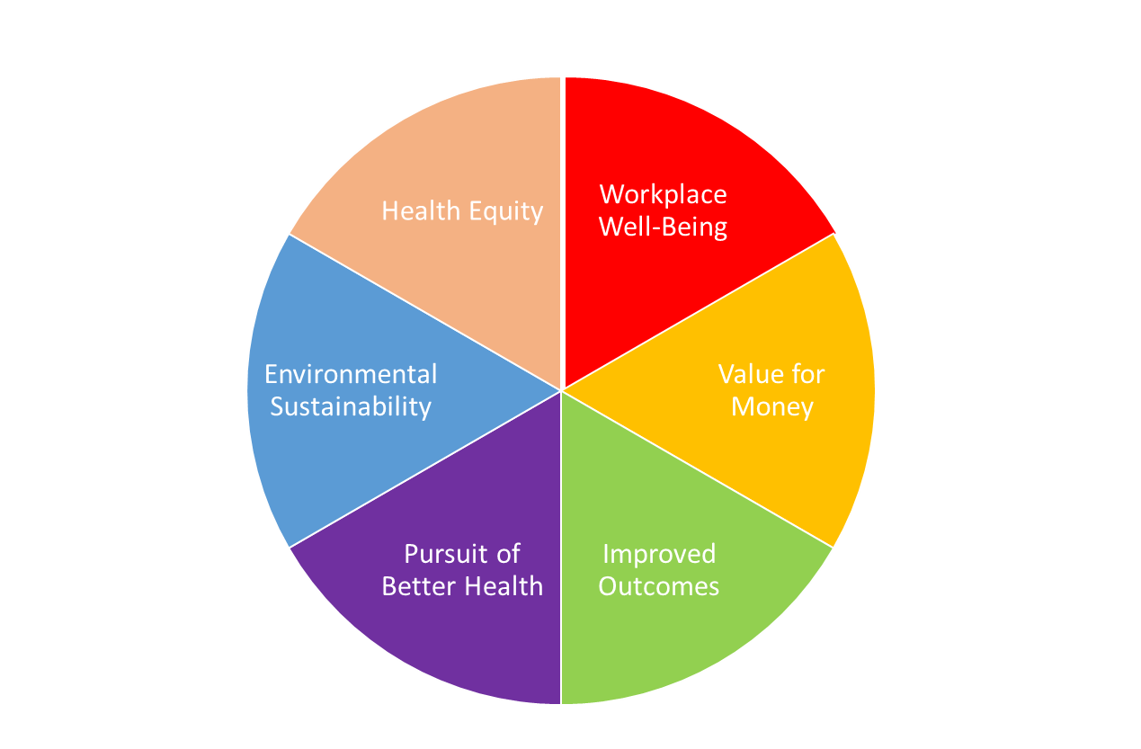

Figure 1. the Sextuple Aims of the NL Learning Health and Social System

